**A PROPOSED OFFERING OF A HOTEL RESERVATION MANAGEMENT SYSTEM FOR EUROTEL NORTH EDSA**

A Requirement Specification Document Presented to the

Faculty of Datamex College of Saint Adeline, Inc.

In Partial Fulfillment of the Requirements for the

Degree of Bachelor of Science in Information Technology

Presented by:

Adarayan, Jessie

Anacta, Francis Rico

Bernadas, Marjorie

Pedro, Pamela Anne

## **INTRODUCTION**

Eurotel North Edsa Hotel serves different kinds of guests such as business travelers, families, and casual visitors. However, its current reservation process still faces several challenges, including slow check-ins, unclear room availability, and delays in booking procedures. Since many tasks are done manually, both admin and customers often experience long waiting times and inefficiency. To address these issues, this document presents the requirements for a system that aims to improve and modernize the hotel’s reservation process, making it easier for admin to manage and more convenient for guests to use.

The proposed Hotel Reservation Management System is designed to solve these problems by offering two main booking options: online reservations that can be made anytime and walk-in reservations that can be confirmed directly at the front desk. The system will provide real-time updates on room status, showing whether a room is available, occupied, or under maintenance. Through this system, check-in and check-out will become faster, the workload of hotel admin will be reduced, and guests will have a more organized and reliable experience.

This document outlines the key functions of the system, such as managing online and walk-in bookings, monitoring room availability, processing payments, and storing guest information securely. It also sets quality standards, including system security, dependability, and ease of use. Although the system is mainly designed for Eurotel North Edsa Hotel, it can also be adjusted for future use in other branches.

In conclusion, this requirements specification provides a clear description of the proposed system. By addressing the needs of both hotel admin and guests, the Hotel Reservation Management System aims to improve efficiency, protect guest information, and enhance the overall service quality of Eurotel North Edsa Hotel.

## **FUNCTIONAL REQUIREMENTS**

This section lists the main functions that the Hotel Reservation Management System must perform to meet the needs of both guests and hotel admin. It covers account registration and login, online and walk-in reservations, room management, over-the-counter payments, notifications, and admin reporting. Each requirement specifies its priority, dependencies, and acceptance criteria.

|  |  |  |  |  |
| --- | --- | --- | --- | --- |
| Requirement  ID | Requirement Description | Priority | Dependencies | Acceptance Criteria |
| FR-01 | Online guests can register with their personal details such as name, contact number and email address. | High | None | The account is successfully stored in the system. |
| FR-02 | Online Guests can log in using their personal credentials. | High | FR-01 | The guest is able to enter their account dashboard after login. |
| FR-03 | Online guests can book a room online by selecting room type, date, and duration of stay. | High | FR-01 | Reservation is recorded in the system and confirmation is displayed to the guest. |
| FR-04 | Walk-In guests can be registered and booked directly by hotel admin at the front desk. | High | None | Admin records guest information and reservation, and the system updates room availability. |
| FR-05 | The system updates room status (available, reserved,occupied, under maintenance) instantly after every booking, cancellation, or check-out. | High | FR-03, FR-04 | Room status is accurate and up to date in the system. |
| FR-06 | Online guests can cancel or modify their booking before check-in. | Medium | FR-03 | Reservation changes are reflected in the system and room availability is updated. |
| FR-07 | Payment for both online and walk-in reservations are handled over the counter during guest check-in. | High | FR-03, FR-04 | Admin marks the payment as completed in the system and reservation status is updated. |
| FR-08 | The system can send bookings confirmation and reminders to online guests. | Medium | FR-03, FR-07 | Guest receive confirmation after booking and reminder notification before check-in. |
| FR-09 | Administrators can generate reports on registration, payments, and room occupancy for both online and walk-in guests | Medium | FR-3, FR-04, FR-O7 | Admin can access and download accurate reports on the system. |

## *Table 1: Functional Requirements*

## 

## 

## 

## 

## **NON-FUNCTIONAL REQUIREMENTS**

This section defines the system’s quality attributes, including performance, usability, reliability, security, scalability, and maintainability. It ensures the system operates efficiently, is user-friendly, secure, and can handle future growth while being easy to maintain and update.

|  |  |
| --- | --- |
| Category | Description |
| Performance | The system must process room availability searches and reservation within 3 seconds and handle up to 150 simultaneous users without slowing down. |
| Usability | The interface must be straightforward and user-friendly, allowing guests to book rooms and admin to manage reservations with minimal training. |
| Reliability | The system should maintain an uptime of at least 99% with automatic data backups to secure reservation records and prevent booking conflicts such as double reservations. |
| Security | Guest personal data and booking records must be protected using encryption. Admin access should be role-based, ensuring sensitive information is only available to authorized personnel. |
| Scalability | The system must accommodate growth in hotel operations, such as adding new branches or increasing user traffic, without compromising performance. It should scale to support up to 500 simultaneous users and integrate with third-party services like payment gateways or property management tools. |
| Maintainability | The system must be developed using modular, well-documented code to allow for efficient updates, bug fixes, and feature enhancements. It should support routine maintenance with minimal downtime and enable quick onboarding of new developers or IT admin. |

## *Table 2: Non-Functional Requirements*

## 

## 

## 

## 

## 

## **USE CASES**

Use case shows how a user interacts with a system to perform a specific task, highlighting the actions taken by the system and the expected outcome.

**Use Case 1**

* Use Case ID: 1
* Use Case Name: Online Reservation
* Description: A guest books a hotel room online via the Hotel Reservation Management System. The system verifies availability, collects guest information, confirms the reservation, and updates the room status in real-time.
* Actors: Guests (online/walk-in), Hotel Reservation System, Hotel Admin
* Preconditions:
* Guests have internet access.
* The system is online and connected to the database.
* Postconditions:
* Reservation is confirmed, and a booking reference is generated.
* Room status is updated as "Reserved."
* Alternate Flows:
* Guests cancel before confirming their reservation.
* No available rooms for selected dates (system displays alternatives).

**Use Case 2**

* Use Case ID: 2
* Use Case Name: Walk-in Reservation
* Description: A guest will go to the front desk without prior booking to reserve a room, Admin will use the system to see the room availability, record the guest information, confirm payment, and assign a room immediately.
* Actors: Guests (walk-in), Hotel Reservation System, Hotel Admin
* Preconditions:
* Guests arrive at the hotel.
* Admin are logged into the reservation system.
* Postconditions:
* Reservation is created and room status updated to "Occupied" or "Reserved."
* Guests receive room keyS and check-in details.
* Alternate Flows:
* Guests cancel before confirming their reservation.
* No available rooms for selected dates (system displays alternatives).

**Use Case 3**

* Use Case ID: 3
* Use Case Name: Monitor Room Availability
* Description: Admin check real-time room status using the system to identify available, occupied, or under-maintenance rooms.
* Actors: Front Desk Admin, Hotel Reservation System
* Preconditions:
* The system is running and synced with the database.
* Postconditions:
* Admin receive accurate room availability data.
* Alternate Flows:
* Database connection failure (system cannot retrieve updated information).
* System downtime requiring manual room checks.

**Use Case 4**

* Use Case ID: 4
* Use Case Name: Process Payment
* Description: The system processes guest payments (at front desk), records transactions, and updates booking status.
* Actors: Guests, Hotel Admin, Hotel Reservation System
* Preconditions:
* Guest confirms booking.
* Payment methods are available (cash, credit card).
* Postconditions:
* Payment confirmation is generated and stored in the system.
* Reservation status updated to "Confirmed."
* Alternate Flows:
* Payment authorization fails (guest is prompted to retry).
* Guests choose to pay later (reservation marked as "Pending").

**Use Case 5**

* Use Case ID: 5
* Use Case Name: Store Guest Information Securely
* Description: The system records and encrypts guest personal details to comply with privacy standards.
* Actors: Hotel Reservation System, MySQL Database, Front Desk Admin
* Preconditions:
* Admin have authorized access to the system.
* Database security protocols are active.
* Postconditions:
* Guest data is securely stored and can be retrieved only by authorized personnel.
* Alternate Flows:
* Unauthorized access attempt detected (system triggers security alert).
* Database backup failure (manual backup procedure required).

## 

## 

## 

## 

## **DATA REQUIREMENTS**

The Hotel Reservation Management System needs organized information to handle guest records, room availability, admin activities, booking details, and payment transactions. Having well-structured data ensures that reservations are processed correctly, check-ins and check-outs are faster, and overall hotel operations run smoothly. This also helps the hotel admin reduce manual work while giving guests a convenient and reliable experience.

**Data Entities and Attributes**

1. **Guest**

* Guest ID (PK)
* Full Name
* Date of Birth / Age
* Gender
* Contact Number
* Email Address
* ID/Passport Number
* Address
* Booking History (Previous Reservations, Stay Records)
* Date Registered

1. **Reservation**

* Reservation ID (PK)
* Guest ID (FK → Guest)
* Room ID (FK → Room)
* Admin ID (FK → Admin)
* Check-in Date and Time
* Check-out Date and Time
* Reservation Status (Booked, Checked-in, Checked-out, Cancelled)
* Payment Status (Pending, Paid, Refunded)
* Mode of Payment (Over-the-counter)
* Notes / Special Requests
* Date Registered

1. **Room**

* Room ID (PK)
* Room Number
* Room Type (Single, Double, Suite, etc.)
* Maximum Occupancy
* Room Rate
* Current Status (Available, Occupied, Under Maintenance)
* Room Features (Wi-Fi, Aircon, TV, etc.)
* Date Registered

### **4. Payment**

* Payment ID (PK)
* Reservation ID (FK → Reservation)
* Amount
* Payment Method (Over-the-Counter Only – Cash, Credit/Debit Card)
* Payment Status (Paid, Failed, Refunded)
* Payment Date
* Receipt Number
* Processed By (FK → Admin)

### **5. Admin**

* Admin ID (PK)
* Full Name
* Role (Admin)
* Contact Number
* Email Address
* Username / Login ID
* Password (Encrypted)
* Employment Status (Active, On Leave, Terminated)
* Date Joined
* Last Login

**Relationships**

Guest → Reservation: A guest can make one or more reservations.

Reservation → Room: Each reservation is linked to one room.

Room → Reservation: A room can be reserved multiple times over different dates.

Reservation → Admin: Each reservation is processed or managed by a admin member.

Admin → Reservation: A admin member can manage multiple reservations.

Reservation → Payment: Each reservation has one corresponding payment record.

Payment → Admin: Each payment is processed by a admin member.

Admin → Payment: A admin member can process multiple payments.

## **ASSUMPTIONS AND CONSTRAINTS**

This section outlines the conditions expected to be true during system development and implementation, as well as the limitations that may affect the system’s design, performance, and operation

**Assumptions**

* Guests who book online are expected to have internet access and a device they can use to open the reservation system.
* Hotel admin can operate the system and will be trained to use its basic features for handling bookings.
* The hotel has worked computers and a stable network to make sure the system runs without problems.
* Information given by guests, such as their names, contacts, and booking details, is assumed to be correct and honestly provided.
* Most transactions, like walk-ins and check-ins, will happen during the hotel’s normal working hours, but online reservations can still be made anytime.
* Both admin and guests are expected to use updated browsers or devices that work well with the system.
* The hotel will follow data privacy rules and apply security measures to keep guest information safe.

**Constraints**

* Payment processing is limited to the method supported by the hotel (over the counter).
* Only authorized hotel admin can access the system’s administrative features.
* The system will only handle reservations for Eurotel North Edsa and not for other hotel branches.
* Hardware and software upgrades are limited to the hotel’s approved budget.
* The reservation system must comply with existing hotel policies and government regulations.
* User accounts and access levels will be limited to predefined roles (e.g., admin, guest).

## **GLOSSARY**

This section lists key terms and their definitions used in the document. It provides a quick reference for understanding the system’s terminology.

* Maintenance – The process of repairing or preparing a room to ensure it is ready for the next guest.
* Efficiency – The ability of the system to complete hotel processes quickly and effectively with fewer errors.
* Dependability – The reliability of the system to function correctly at all times without frequent breakdowns.
* User-Friendly – A system design that is simple and easy to use for both admin and guests.
* Front Desk – The reception area where hotel admin assist guests with reservations, inquiries, and services.
* Check-in – The procedure where guests officially register at the hotel before occupying a room.
* Check-out – The process of leaving the hotel, which includes settling payments and returning room keys.
* Encryption - The method used to protect sensitive guest data by converting it into a secure format.
* Role-Based Access - A system feature that restricts data access based on user roles (e.g., guest, admin).
* Guest Profile - A collection of personal and booking-related information stored for each guest.
* Database - The storage system used to organize and manage hotel-related data like bookings and guest profiles.
* Reservation - A record of a guest's request to occupy a hotel room for a specific period.
* Online Booking - A reservation made through the hotel’s online system or website.

## **REVISION HISTORY**

This section records all modifications made to the design document throughout its development. Each entry lists the version number, the date of the update, and a brief description of the changes. It helps track progress, maintain accountability, and provide a clear history of the system

|  |  |
| --- | --- |
| DATE | CHANGES MADE |
| August 22,2025 | Added the Functional Requirements |
| August 23, 2025 | Added the Data Requirements and Constraints |
| August 24, 2025 | Added Glossary |
| August 25, 2025 | Added the Appendix A and B |
| August 26, 2025 | Reviewed the paper |
| August 30, 2025 | Revision of paper |
| August 31, 2025 | Revision of paper and UI design |

*Table 3: Revision History*

## 

**APPENDIX**

This section presents the screenshots of the developed system, showcasing its user interface and core functionalities. Each figure highlights the design and interaction flow of the Hotel Reservation Management System for Eurotel North Edsa Hotel.

**Appendix A: Mockups**

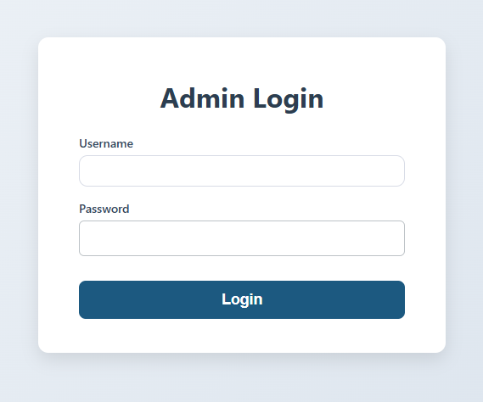

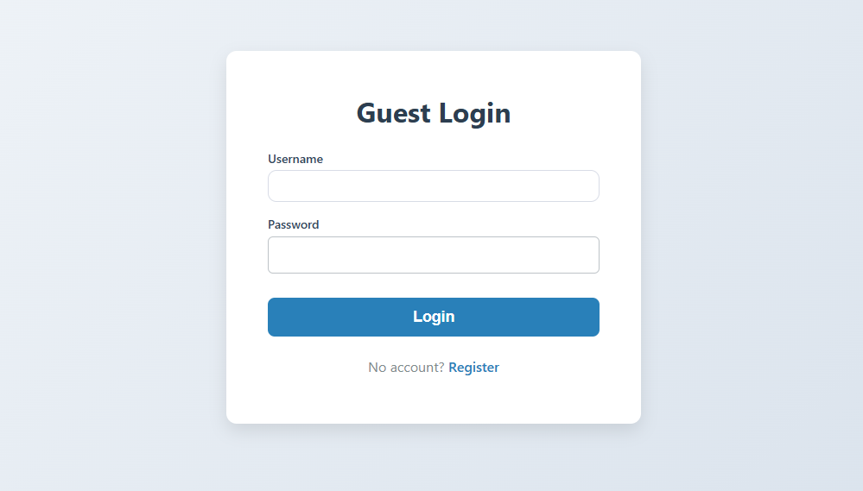*Image A.1: Log-In Form*

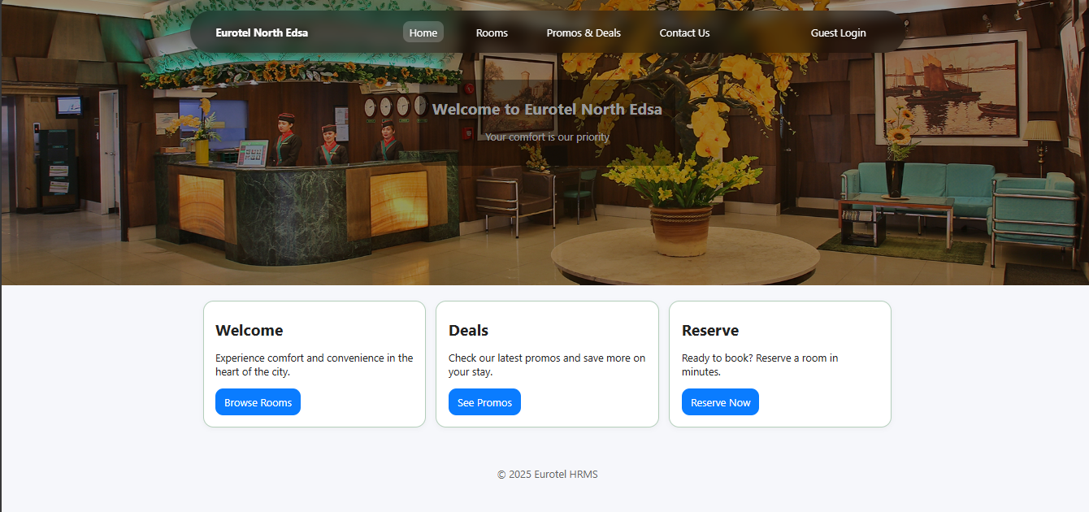

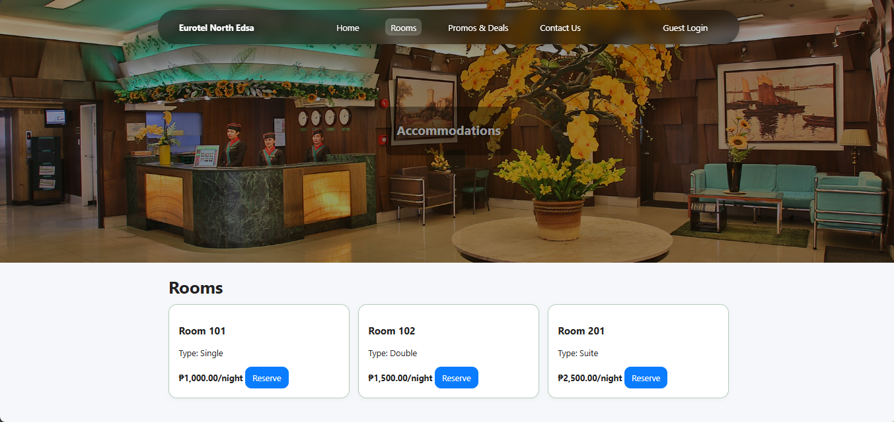

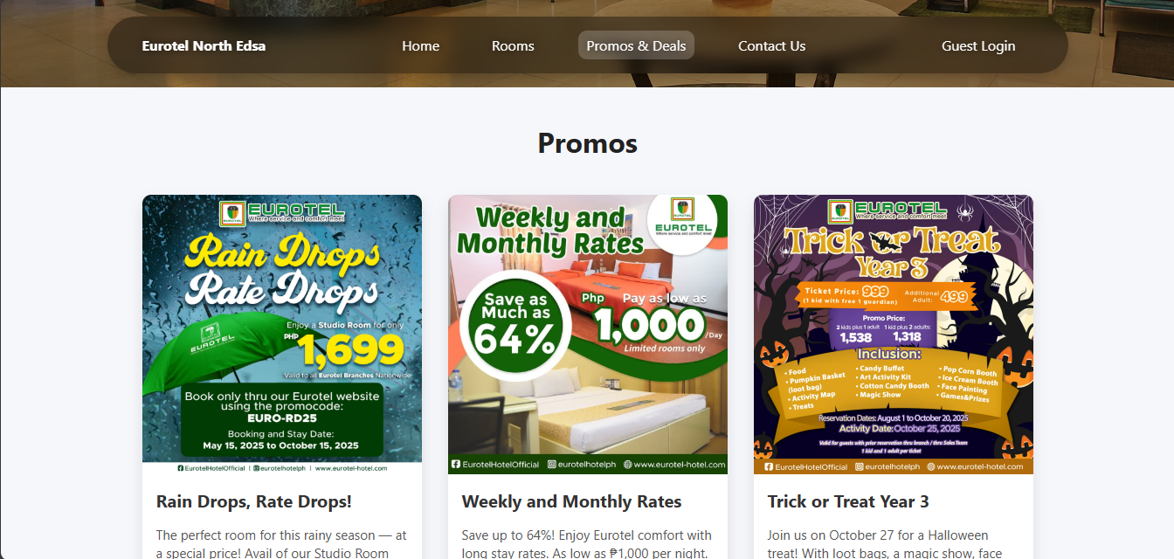

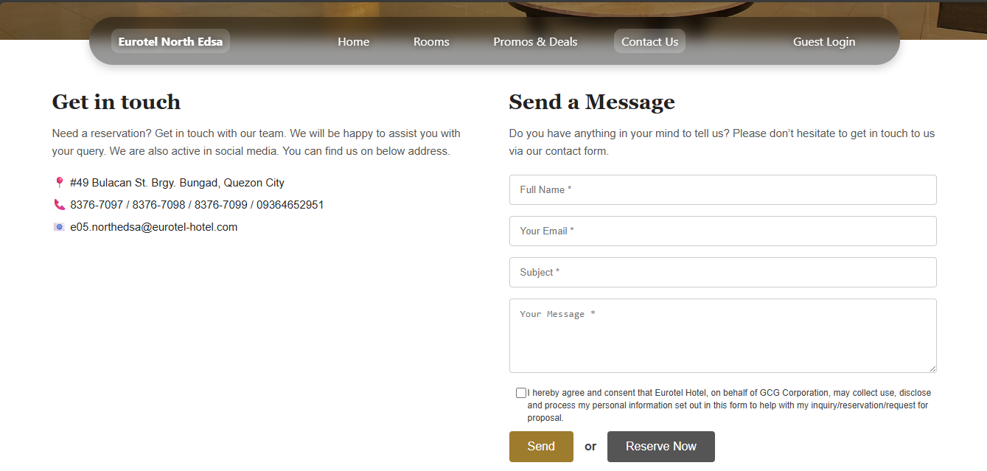

*Image A.2: Dashboard*

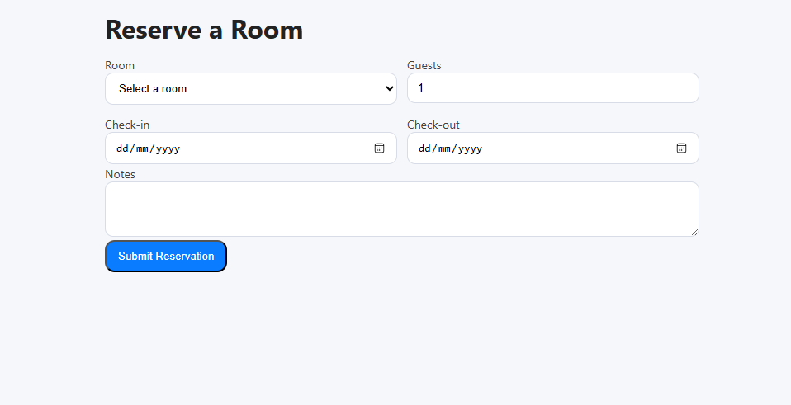

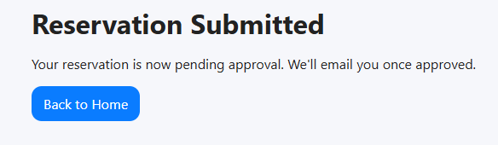

*Image A.3: Reservation Form*

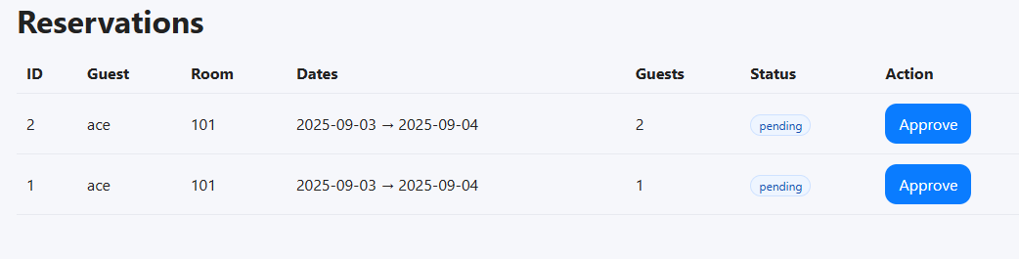

*Image A.4: Managing Reservation Rooms*

**Appendix B: Diagram**

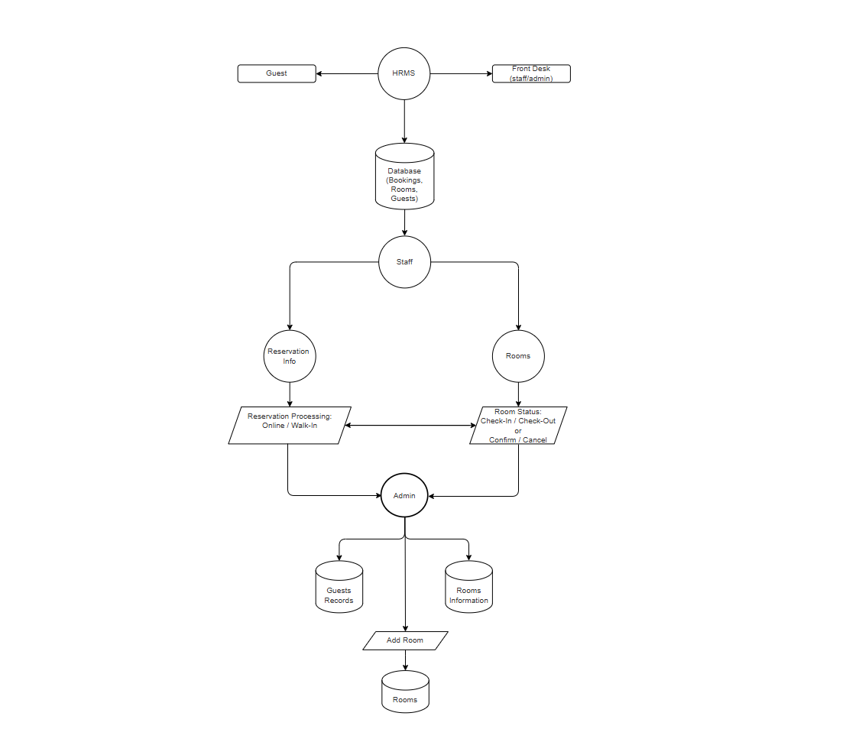

*Image B.1: Data Flow Diagram*